Operation Manual
ECE Team #3
Smart Streetlight Proof of Concept

Members:

Tucker Russ (tr13f)
Brandon Berry (blb14f)
Thor Cutler (tc11f)
Anthony Giordano (afg11)

Faculty Advisors

Dr. Victor DeBrunner
Dr. Leonard Tung

Sponsor
FSU/FAMU College of Engineering Entrepreneurial Department
Instructor

Dr. Michael Devine
Dr. Jerris Hooker
Date Submitted
April 4, 2016

Table of Contents
Table of Contents
1. ABSTRACT 7
2. Introduction 9
1.1 Need Statement 9
1.2 Goal Statement 9
1.3 Constraints 9
3. Components 11
1.4 User Interface 11
1.5 Electrical System 13
1.5.1 Circuit Details 13
1.5.2 Battery Details 14
1.5.3 Power Supply Details 15
1.6 3D Printed Housing 16
4. Software Setup/Operation 18
1.7 Open the Program 19
1.8 Parts of the Program 20
1.8.1 Main Menu 20
1.8.2 Receive Signals from Network and Save to Packet List 21
1.8.3 Reading Packet File and Displaying the Results 21
1.8.4 View Incoming Packets in Real-Time 22
5. Product Assembly 28
6. Troubleshooting 35
7. Regular Maintenance 37
References 38

Table of Figures
Figure 1 - Eleduino Kit 11
Figure 2 - XBee with Explorer 12
Figure 3 - Top-Down User Interface 12
Figure 4 - Circuit Schematic 13
Figure 5 - Lithium-ion Battery 14
Figure 6 - Power Supply 15
Figure 7 - Top Part 85 x 55 x 5 (mm) 16
Figure 8 - Main Part 87 x 57 x 127 (mm) 16
Figure 9 - Stand Part 20 x 20 x 127 (mm) 17
Figure 10 - Combined Final Housing 107 x 77 x 254 (mm) 17
Figure 11 - User Interface Power Button 18
Figure 12 - Part one of Reading Packet File and Displaying Results Function 23
Figure 13 - Part 2 of Reading Packet File and Displaying Results Function 24
Figure 14 - Receiving Packets and Saving Them to a File Function 25
Figure 15 - View Packets from Network Function 26
Figure 16 - Menu Options Linking to the Three Functions 27
Figure 17 - Plexiglass Attached 29
Figure 18 - Plexiglass Support 29
Figure 19 - Streetlight Housing Mounting 30
Figure 20 - Top Housing with Power Cable Fed 30
Figure 21 - Top Housing with Circuit 31
Figure 22 - Arial Housing/Circuit View 31
Figure 23 - Streetlight with Removable Base 32
Figure 24 - Removable Base Area on Cart 32
Figure 25 - Street Design 33
Figure 26 - Power Converters 33
Figure 27 - UI Keyboard (LCD not mounted yet) 34

Table of Tables

Table 1 - Project Constraints ………………………………………………………………………………………………10

ABSTRACT
The objective of this report is to provide insight on how to assemble, operate, and maintain the Smart Streetlight Proof of Concept senior design project. This report will give an overview of exactly how the system functions, and how each of its Streetlights are used to simulate different outages that can occur. The procedure for maintaining all aspects of the project will be covered, including replacing parts, proper care, and the basic concepts of each part’s function. This report will analyze the function of all the systems, define their specifications, and provide instructions on their assembly. Each of the three systems will be discussed in detail; electrical systems, User Interface, and the 3D printed parts that make up the housing and buildings on top of the cart. The electrical systems includes the wireless communication between each Streetlight and the circuit that is equipped into each of the Streetlights to check the two types of outages. The User Interface section will discuss the programming of the User Interface and each of the XBee’s contained in the circuit on each of the Streetlights. Additionally it will go into details regarding how to run the programs in order to find the simulated outages by flipping one or more of the two outage switches contained on each Streetlight. Each of the 3D printed parts will be explained along with their CAD drawing and STL files which will be made available through the teams website. After reading this report, an uneducated reader will understand not only how to use Team 3’s Smart Streetlight Proof of Concept, but how to assemble it, maintain it, and even how to fix it if it malfunctions. This Operations manual is the user guide to the Smart Streetlight Proof of Concept senior design project.

ACKNOWLEDGMENTS
Acknowledgements—
FSU-FAMU College of Engineering Entrepreneurial Department: Project Sponsor
Dr. Michael Devine: Entrepreneurial Mentor
Dr. Jerris Hooker: Project Coordinator/Instructor
Committee of Engineering Shark Tank

Introduction

Need Statement
Currently, when a streetlight loses power, it does not have the ability to alert the utility of the outage. A customer must call to report the outage. A contributing factor to this is old outdated technology that has not been improved or updated in decades. The Smart Streetlight project is a design that will change this. When an outage occurs on the streetlight, the status will be transmitted to a user interface that will relay the information to the user. In addition, it will allow the location of the outage to be known, which will greatly improve restore times and allow more information to be determined. For example, multiple outages on the same fuse. The system will work off of two separate checks. The first check will check to see if the Streetlight has power. The next check will check to see if the bulb is simply blown on the Streetlight. This will increase the effectiveness of knowing the issue before physically being at the Streetlight in the field. The streetlights or household power status will communicate through a wireless XBee network and connect peer to peer in order for their current statuses to be accessed. A node placed on each street light will communicate wirelessly with a single central station where the information will then be accessible on a user interface. The signal will travel through a Peer-to-Peer (P2P) network allowing for increased range.

Goal Statement
This team will be focusing on building a small scale model that will fulfill the needs statement and will be easily scaled up for real world use while making it easy for an uneducated person to visual see an outage and how the entire system responds to it through the User Interface.

Constraints
Budget | $1,500
Deadline | 2nd week of April
Power | 5v DC Power Supply each Streetlight
Control | Integrated RaspBerry Pi 2
Display | Portable 3 story cart w/ wheels and plexiglass
Goal | Have wireless communications with Streetlights in order to recognize outages when they happen (either no power or bulb blown outages).
Max Power Each Streetlight | 5V DC Power
Cart Dimensions | 18 in x 35-1/4 in x 37-1/4 in
Frequency of XBees | 802.15.4 Stack (the basis for Zigbee)
Range of XBees | 300 ft Outdoor and 100ft Indoor
Streetlight Body | 3D printed with 107 x 77 x 254 (mm) dimensions
User Interface Screen Dimensions | User interface screen will be 10 inches which will allow the program that checks for outages to be seen easily by the user.
Table 1 – Project Constraints

Components

User Interface
The User Interface is made up of a Raspberry Pi 2 which was purchased in a kit including the 10” LCD screen called the Eleduino Raspberry Pi 2 super integrated computer kit as depicted in fig 1. The UI is the central communication between the XBee P2P Network and is equipped with an XBee connected to the pins of the Raspberry Pi. XBee devices are configured using X-CTU, a free multi-platform application by Digi. X-CTU allows each XBee device to be flashed with personal settings, such as using a certain pin as a digital input. This initial setup through X-CTU is done on a computer using an XBee explorer found in fig 2 below. To Control the UI a small keyboard and touchpad combo was purchased to attach to the cart called the Rii Mini K12 as depicted in fig
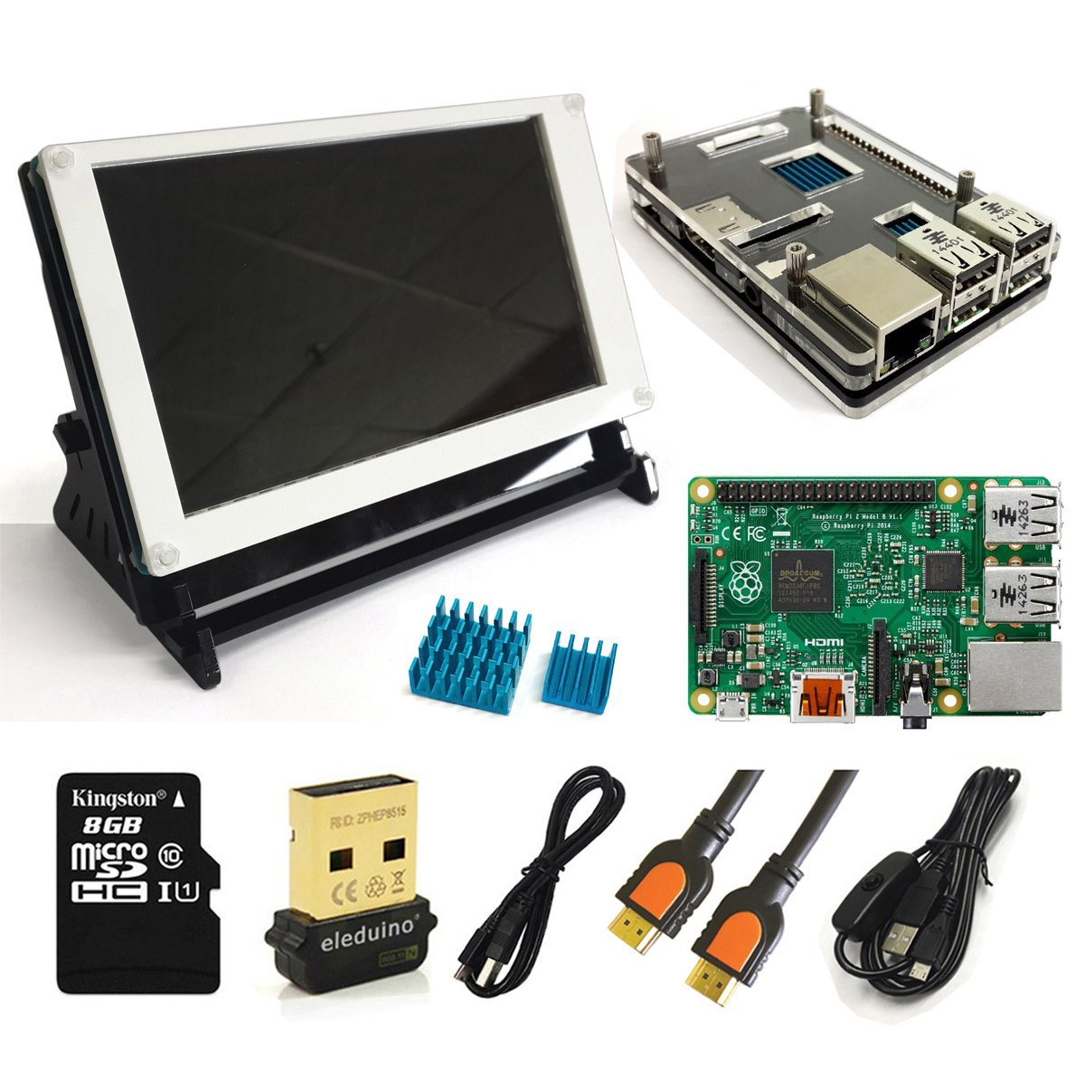
Figure 1 - Eleduino Kit

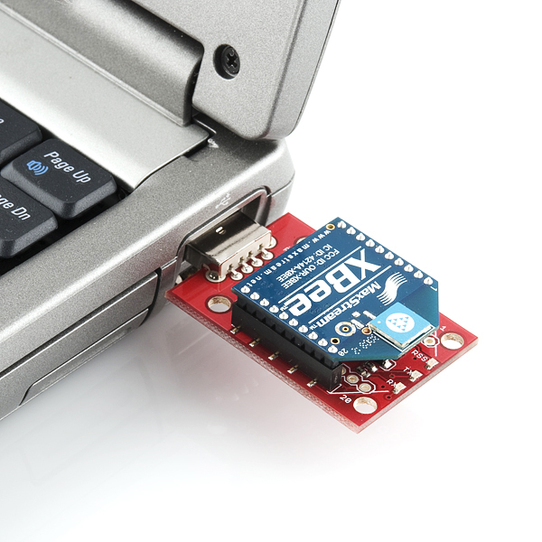
Figure 2 - XBee with Explorer

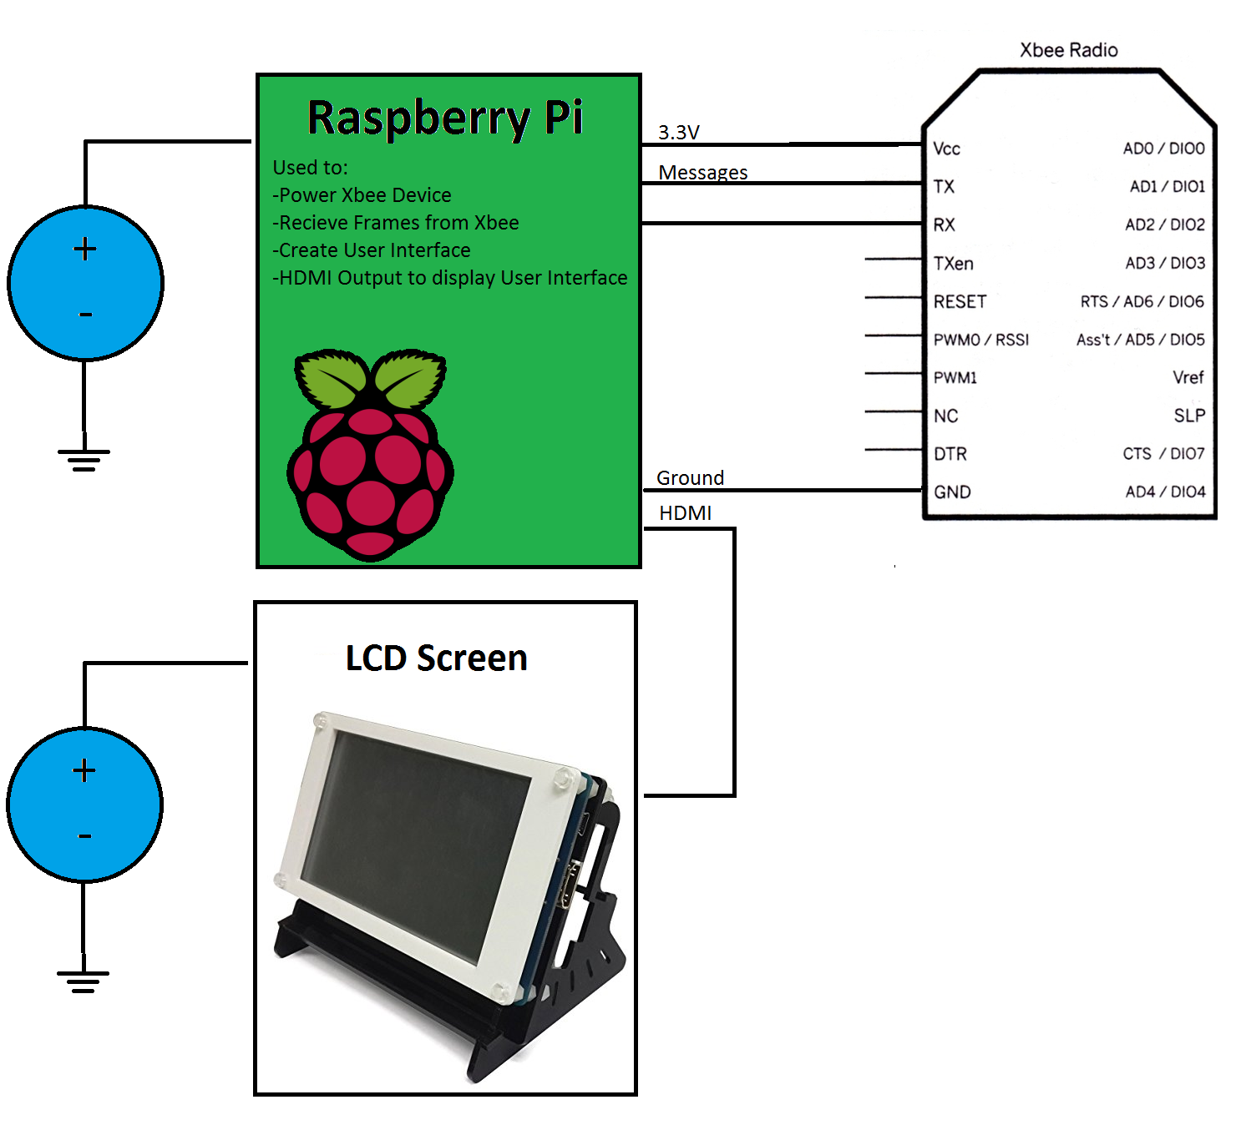
Figure 3 - Top-Down User Interface

Electrical System

Circuit Details
Each Streetlight will contain a Circuit that will allow the XBee to stay on and send data packets while checking for two different types of outages. The first outage it checks for is a main power outage, when all the power is lost to the streetlight. The second outage it will check is when the LED light is blown. There will be two switches in this circuit to simulate both of these outages as depicted in fig 4 below.
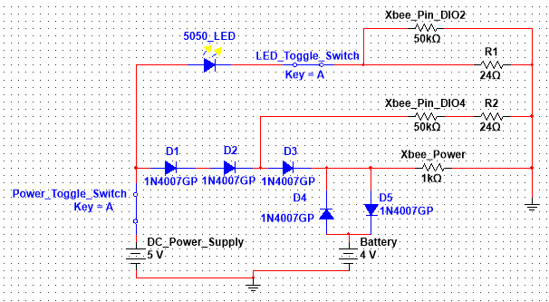
Figure 4 - Circuit Schematic

- The resistors for the XBee power and pins are not actual resistors. They just represent where the circuit connects to the XBee. The pins labeled on the circuit are accurate to the names of the pins on the XBee itself.
- The Power Toggle Switch is used to simulate a power outage. It disconnects the 5 volt power supply from the entire circuit. When this switch is turned off the LED will lose power, but the XBee will still be powered by the battery.
- The LED Toggle Switch is used to simulate a blown LED. This will break the connection from the LED to ground preventing the flow current through the LED. The XBee will continue to receive power directly from the 5 volt power supply.
- D1 – D5 are rectifier diodes.
- The primary function of the diodes D1 – D3 are to prevent the backflow of current from the battery to the XBee checks. This allows for the battery to continue powering the circuit when the main power has been lost without getting false readings on the XBee checks.
- The diodes D1 – D3 also drop the voltage down from 5 volts to a rough 3.4 volts. This is needed in order to not burn up the XBee with a too high voltage input.
- The diodes D4 and D5 are used to drop the batteries voltage from 4 volts to a rough 3.3 volts. They are in opposing direction to allow for the battery to be charged when the 5 volt power supply is connected.

Battery Details

The battery used on each of the circuits is a Lithium-ion 3.7 V 1000mAh battery. The battery is projected to last up to 6 hours on the XBee load, however different variables can effect actual results including how often the XBee sends/receives data packets. Even though the data sheet for the battery shows 3.7V it actually produces 4V of voltage to the circuit which is why the diodes were required. If the model was not in use then it is highly recommended to disconnect the batteries in order to keep them from dying before use again.

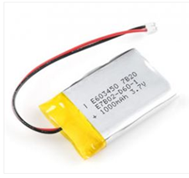
Figure 5 - Lithium-ion Battery

Power Supply Details
A simple 5V cell phone Power Supply is used as depicted in fig 5. It was the cheapest option as the design only requires 5 volts of power and it keeps the XBees powered from a main source under normal operating conditions (non-outages). The XBee wireless transmitter requires 3.3V of DC power. In order to perform the Smart Streetlight proof of concept, DC power cords are used to supply power to each streetlight. The DC power cords are 5V phone chargers that were modified by the Smart Streetlight team. These converters are essential due to their ability to drop the 120V AC to 5V DC power for each streetlight. When scaling the proof of concept up to be manufactured into a device, an AC to DC converter must be configured into the circuit. This will allow for the Smart Streetlight device to be installed into pre-existing AC powered streetlights.

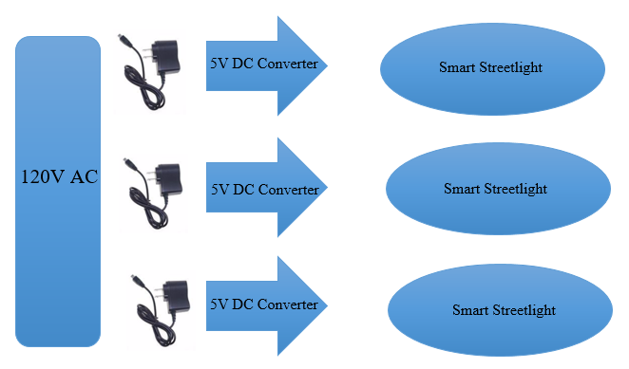
Figure 6 - Power Supply

3D Printed Housing
The components used for the model and housing of the Streetlights were all 3D printed using PLA filament. Each part was designed around the 3D printer’s max print dimensions. The max dimensions for the 3D printer used is 130 mm x 96 mm x 139 mm. The following parts is a list of all the parts designed and printed to complete the project. Each STL file will be uploaded to the team’s website so that if anyone needs to modify or use the files will have access in the future.

Figure 7 - Top Part 85 x 55 x 5 (mm)

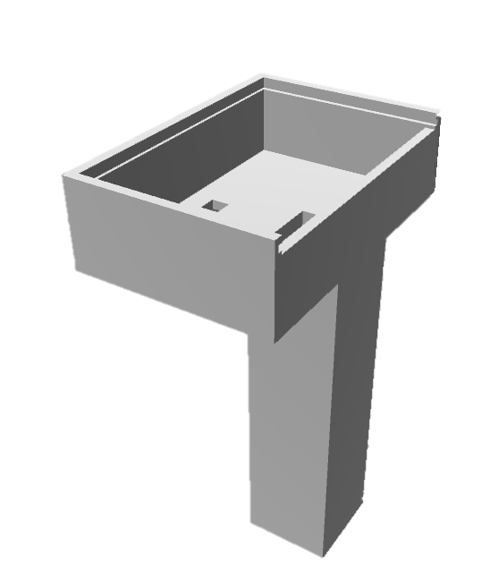
Figure 8 - Main Part 87 x 57 x 127 (mm)
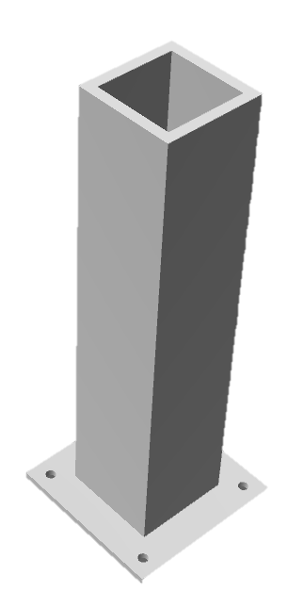
Figure 9 - Stand Part 20 x 20 x 127 (mm)

After each of the parts were printed they were all glued together using Loctite Super Glue. The following result is a clean looking Streetlight housing shown below:
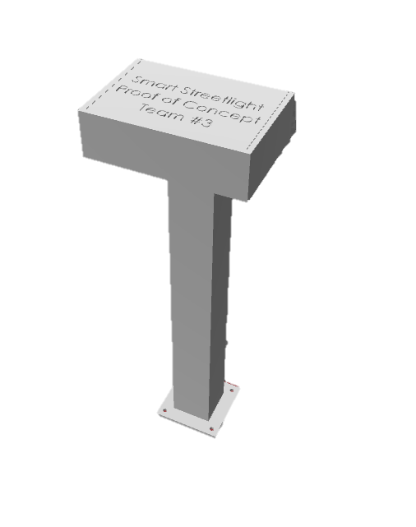
Figure 10 - Combined Final Housing 107 x 77 x 254 (mm)

Software Setup/Operation

Since the design is built on a portable cart it makes the entire setup very simple. The only hardware step is plugging the main power block into a wall. Once this has been done the Raspberry Pi switch will need to be turned on along with the LCD Display as depicted in fig.

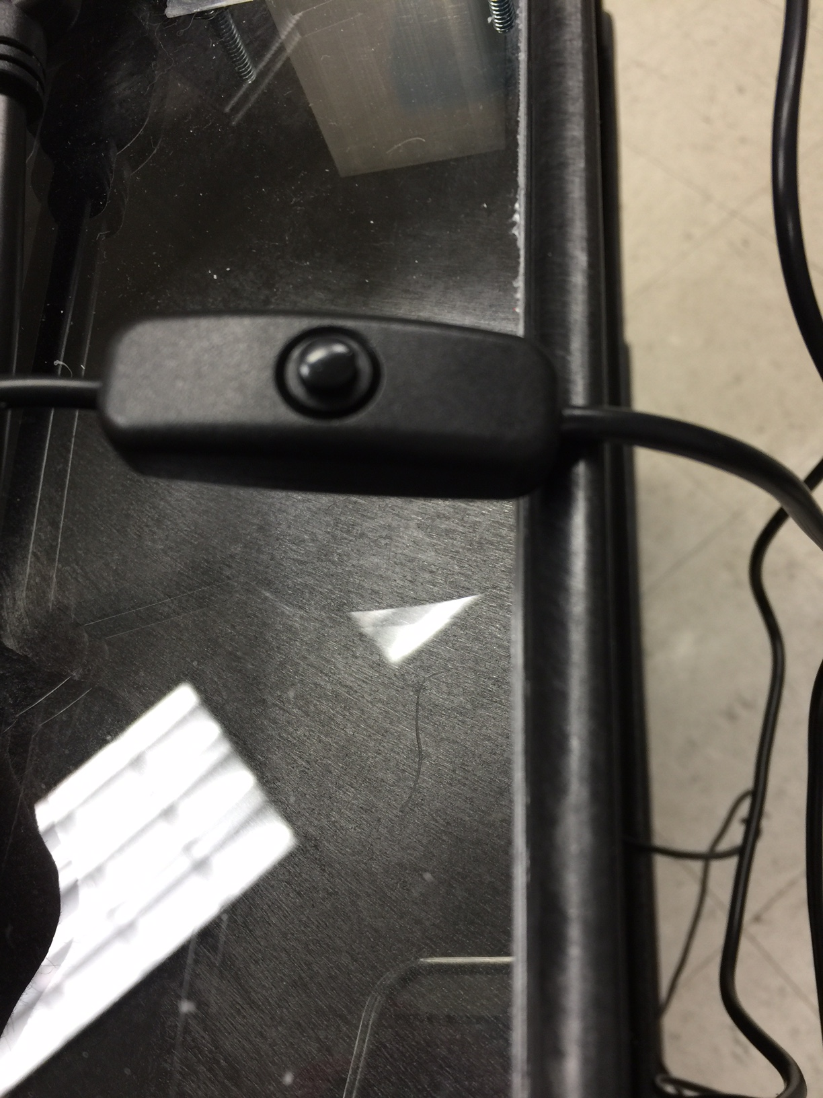
Figure 11 - User Interface Power Button

The User Interface software for the project was written in Python and can be run using Python 3 or higher. However the initial setup of the XBees requires a few settings to be configured in the X-CTU program as discussed earlier before the Python code can be ran.
For Each Streetlight XBee:
Open X-CTU with the XBee plugged into the computer through the USB Explorer. Click the top left Search glass and click “next” and “finish.” The Streetlight XBees are now ready to be configured. Adjust the following categories for each Streetlight:
CH Channel: C
ID PAN ID: 17
16-bit address: First Streetlight=FFFC, Second Streetlight=FFFD, Third Streetlight=FFFE
Scan Channels: 1FFE
Sample Rate: 3E8
D4: DI [3]
D2: DI [3]

To setup the Commander XBee in API mode (XBee that connects to the UI)
CH Channel: C
ID PAN ID: 17
MY 16-bit Address: 0
CE Coordinator Enable: Coordinator [1]
SC Scan Channels: 1FFE
AP API Enable: API enabled [1]
D4 DIO4: Disabled [0]
D2 DIO2: Disabled [0]
CT AT: 64
GT Guard Times: 3E8
CC Command Character: 2B

Open the Program
Once the Raspberry Pi is connected by HDMI to the screen and through GPIO pins to the XBee it can be turned on. After a few seconds it will auto boot to the OS desktop, from there click the SSL User Interface folder and open “user_interface.py” in IDLE for Python 3
Alternately you can go to: Start Menu -> Programming -> Python 3 then when IDLE opens click: File -> Open -> then navigate to the SSL User Interface folder and open “user_interface.py”
Press F5 to run the program once it’s open in IDLE.

Parts of the Program
There are three separate functions in “user_interface.py.” Each function can be accessed from the main menu and perform the different tasks our project set out to perform.

Main Menu
The program loads directly in to the main menu, from here you have three options, each one leading to a different function.
The three options are the following:
- Receive Signals from Network and Save to Packet List
- Analyze Packet List and Display Results
- View Incoming Packets in Real Time

Type a number 1-3 and press enter to select your choice. If an invalid choice is picked the program will re-load the menu.
See fig 16 for an in-depth look at the main menu.

Receive Signals from Network and Save to Packet List
From the main menu typing “1” and pressing enter will start this process. Currently it is set to receive and document 30 packets. With three XBee devices in the network and each one transmitting once per second, this function should take 10 seconds to run. Once it has finished it will print “done…” and tell you to press enter to continue. Pressing “enter” will take you back to the main menu. After running this function a text document will have been created called “packetList.txt.” Running the function again will overwrite this document with the new one.
See fig 14 for an in-depth look at the function.

Reading Packet File and Displaying the Results
From the main menu, typing “2” and pressing enter will start this process. Assuming you have a saved packetList.txt (Created by pressing “1” at main menu) this function will run. After starting the function, the program will automatically read the “packetList.txt” and display the status of the lights.
The output can display two errors:
- Replace Light
- Lost Power
The Replace Light error appears if the light has blown its bulb or LED, replacing it will fix the problem. Lost power appears of the light has completely lost power. In this case the XBee device is running off of battery backup. Re-powering the light will fix this.
If the light is currently running properly it will not appear in the list created by this function (this could be changed by un-commenting out a few lines of code)
Once finished reading the data, press “enter” to return to the main menu.
See fig 12 and fig 13 for an in-depth look at the function

View Incoming Packets in Real-Time
From the main menu typing “3” and pressing “enter” will start this process. The purpose of this function is mostly for diagnosing issues. Running it will display 10 packets, as the system receives them. This function is used to test of the system is set up and receiving packets properly before running other functions. Once it is finished press enter to return to the main menu.
See fig 15, for an in-depth look at the function.

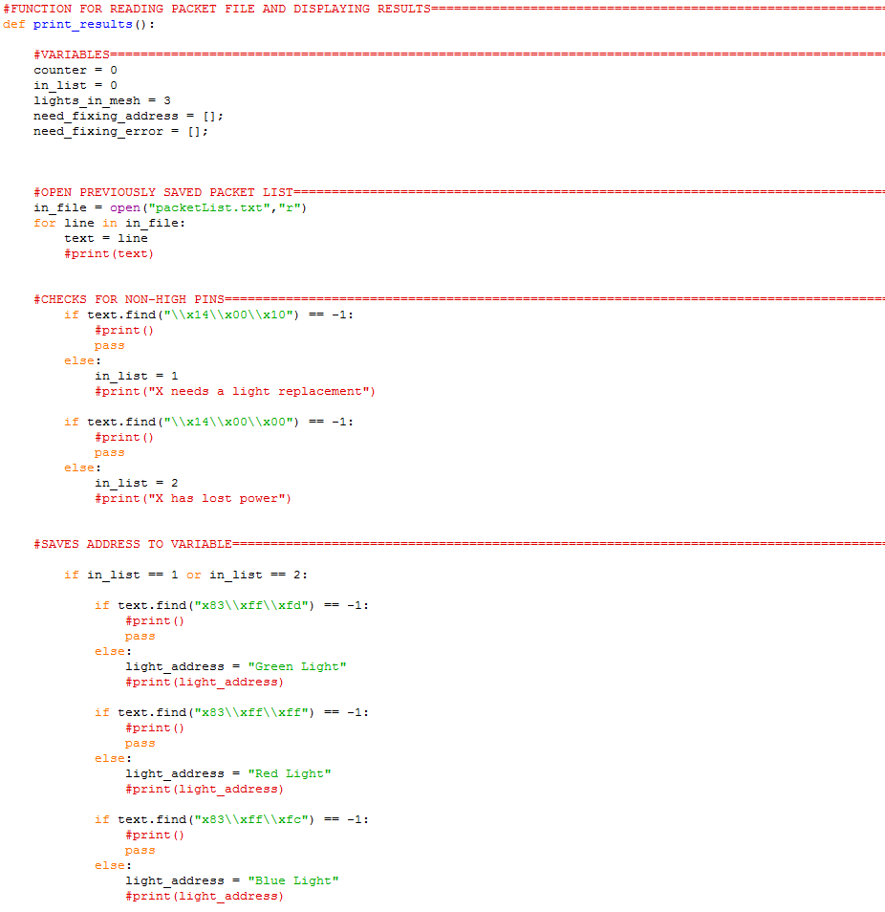
Figure 12 - Part one of Reading Packet File and Displaying Results Function

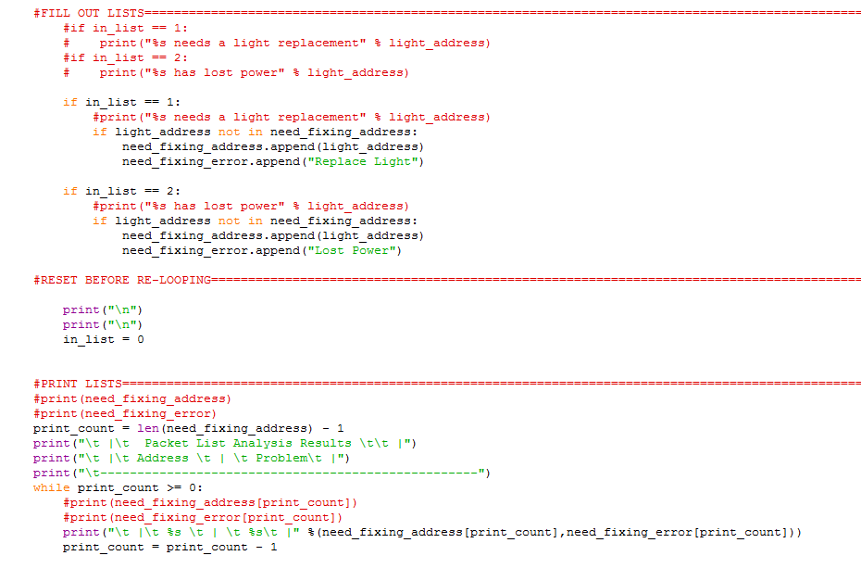
Figure 13 - Part 2 of Reading Packet File and Displaying Results Function

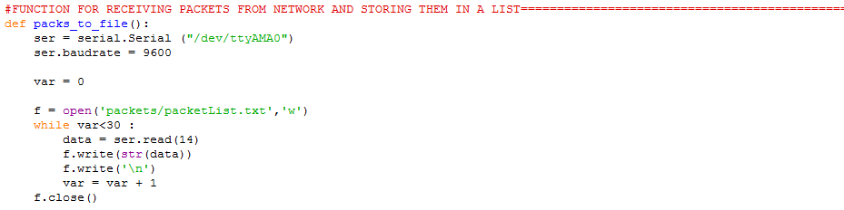
Figure 14 - Receiving Packets and Saving Them to a File Function

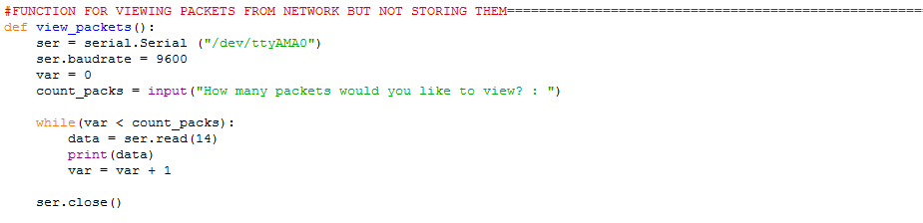
Figure 15 - View Packets from Network Function

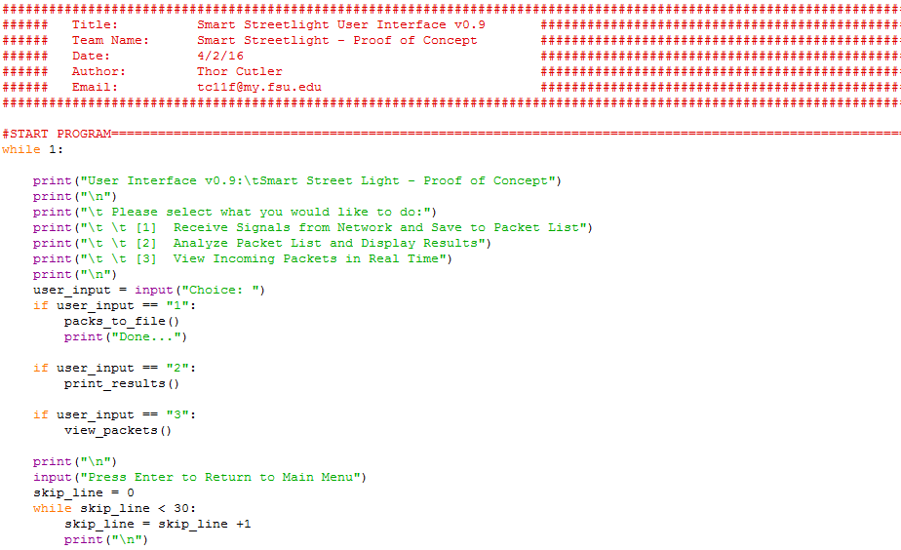
Figure 16 - Menu Options Linking to the Three Functions

Product Assembly
In order to make all power wiring visible, a Plexiglass lid was used to screw all components to so that all details could be observed. The plexiglass fully covers the entire top of the cart and measures 38 ¼ x 16 ¼ as depicted in fig 17. The plexiglass was purchased at Home Depot and then cut to the correct dimensions by the College of Engineering machine shop. Once the plexiglass was finished there needed to be a way for it to sit on top of the cart. So six leg stands were created that were similar to fig 18 of the Streetlight Housing. The difference was they were exactly 2” tall and slightly wider by 1” in order to support the plexiglass better. The pieces were 3D printed as depicted in fig 18. Once this was completed pilot holes were drilled to affix bolts to hold the stands in place on top of the cart. The same bolts were also used to affix the Streetlight housing on to the cart as seen in fig 19. This gives the Streetlights a realistic mount that streetlights currently use today. Once the Housing has been mounted, the finished circuits will now be placed inside with the power cables pushed through the bottom stand and connected to the bottom of the circuit and later soldered as depicted in fig. Two switches are used to control each type of outage and are easily accessible during a simulated outage from the top of the Streetlight as depicted in fig 20. As discussed earlier in this document, there are three total Streetlights on the cart. Two of the Streetlights are permanently mounted to the cart, while the third Streetlight is mounted with Velcro which will allow it to be movable during a simulation to show the distance of the XBees as depicted in fig. In order to make the cart look as real as possible, a Streetlight is drawn on the plexiglass using a large Sharpie marker. To make the yellow road lines, yellow electrical tape was cut to size and then stuck every few inches in the middle of the sketched road. The power strip is then connected on the 2nd shelf of the cart and each Power Supply is plugged in to power each circuit. Once the Streetlights have been assembled, the last part is the User Interface system which will be mounted to the top of a 3D printed building that will display the outages. A small keyboard with built-in mouse will be attached by Velcro to the handle of the cart where the User will stand when the UI is operated as depicted in fig 27.
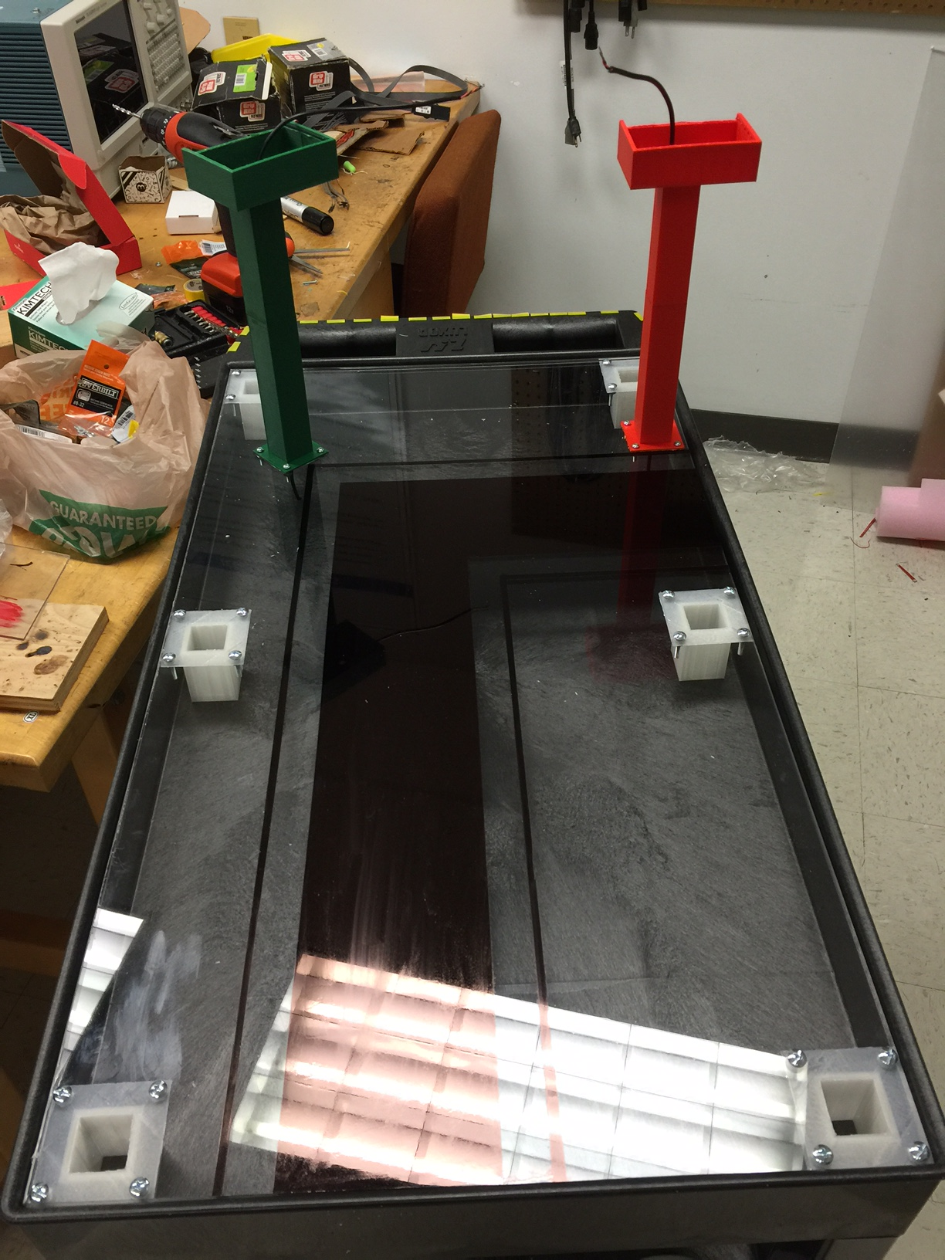
Figure 17 - Plexiglass Attached

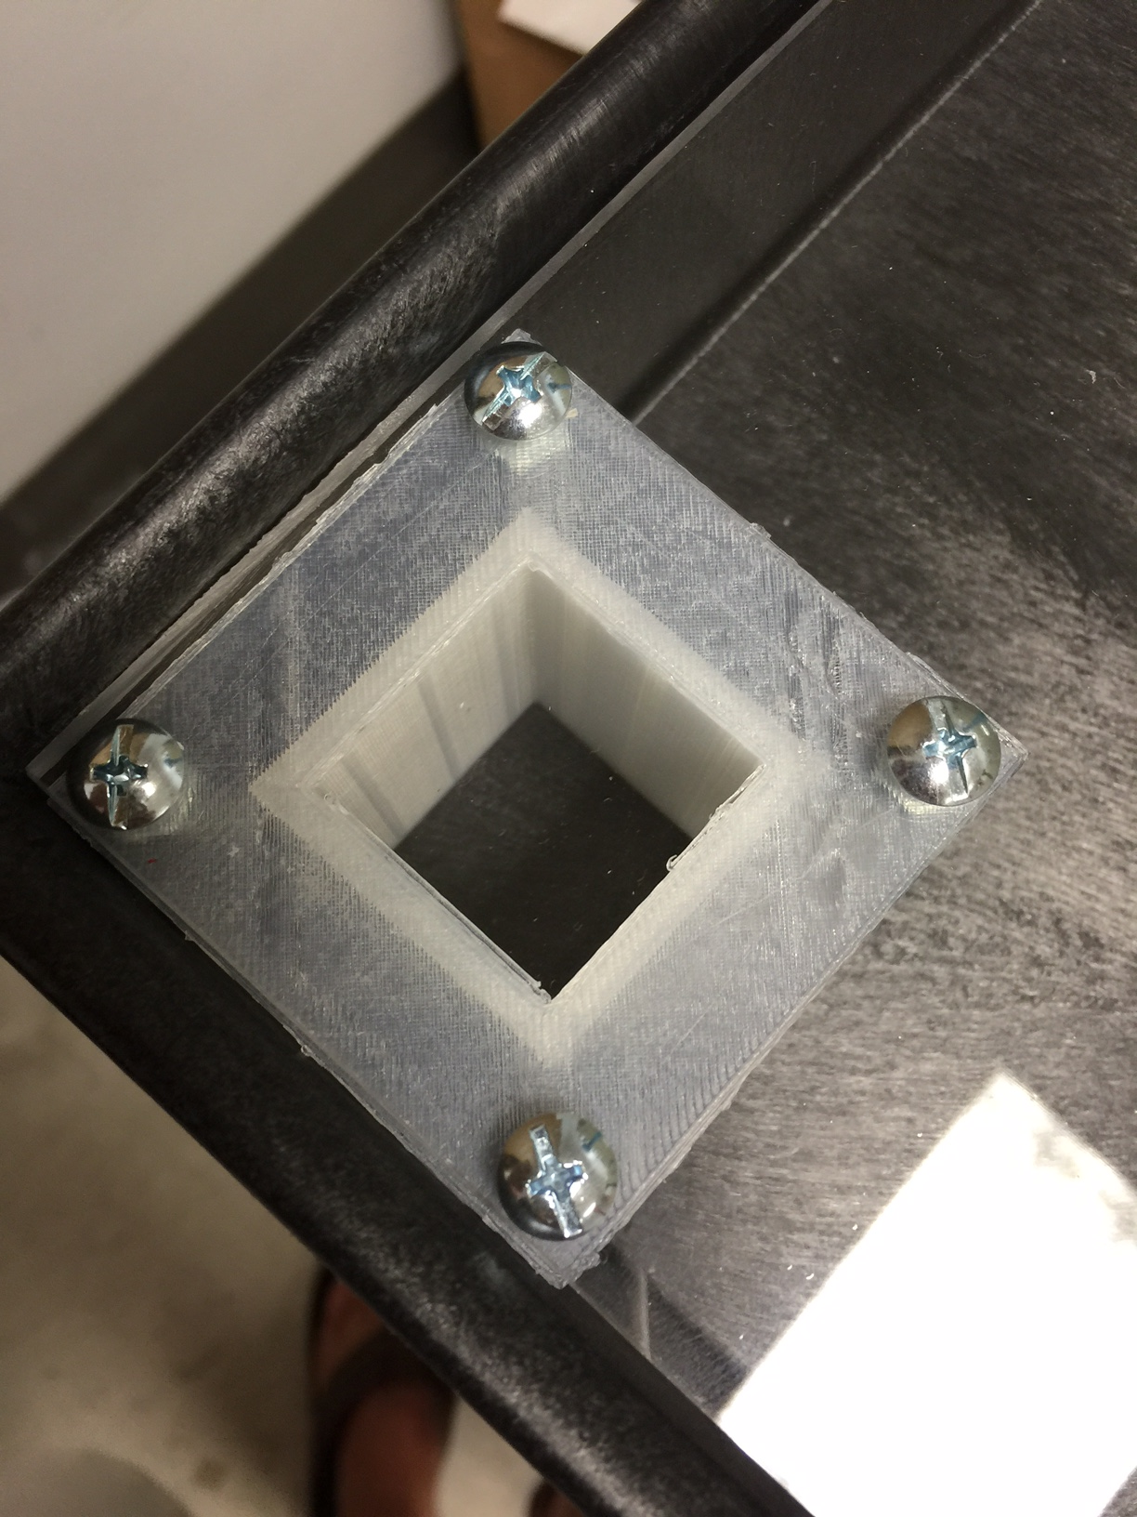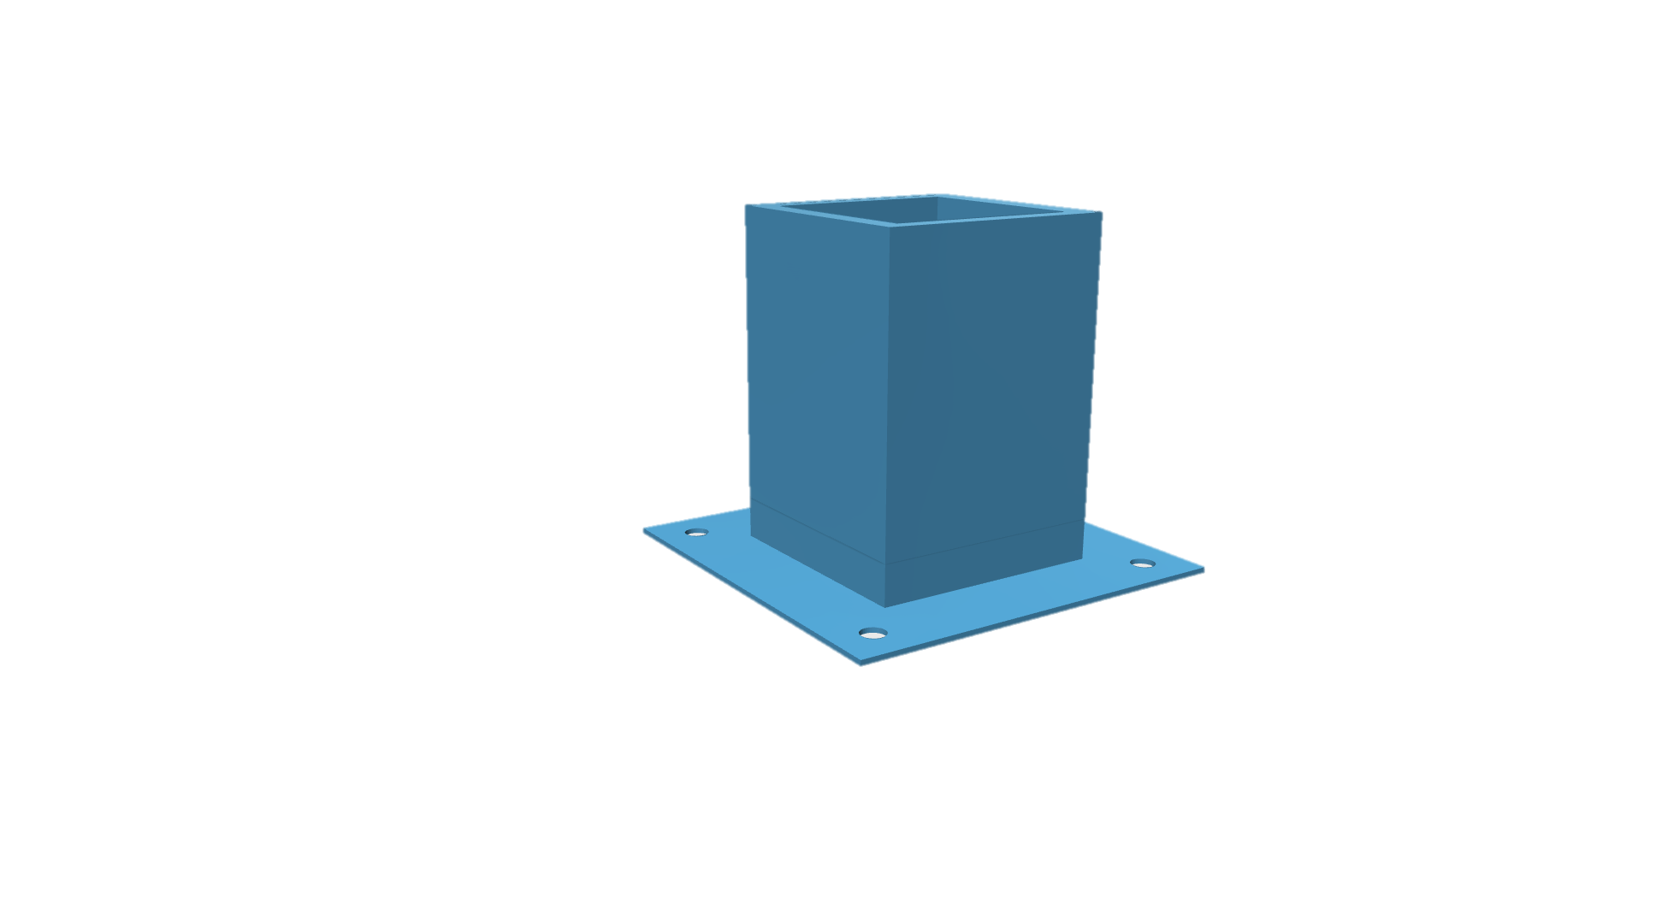
Figure 18 - Plexiglass Support

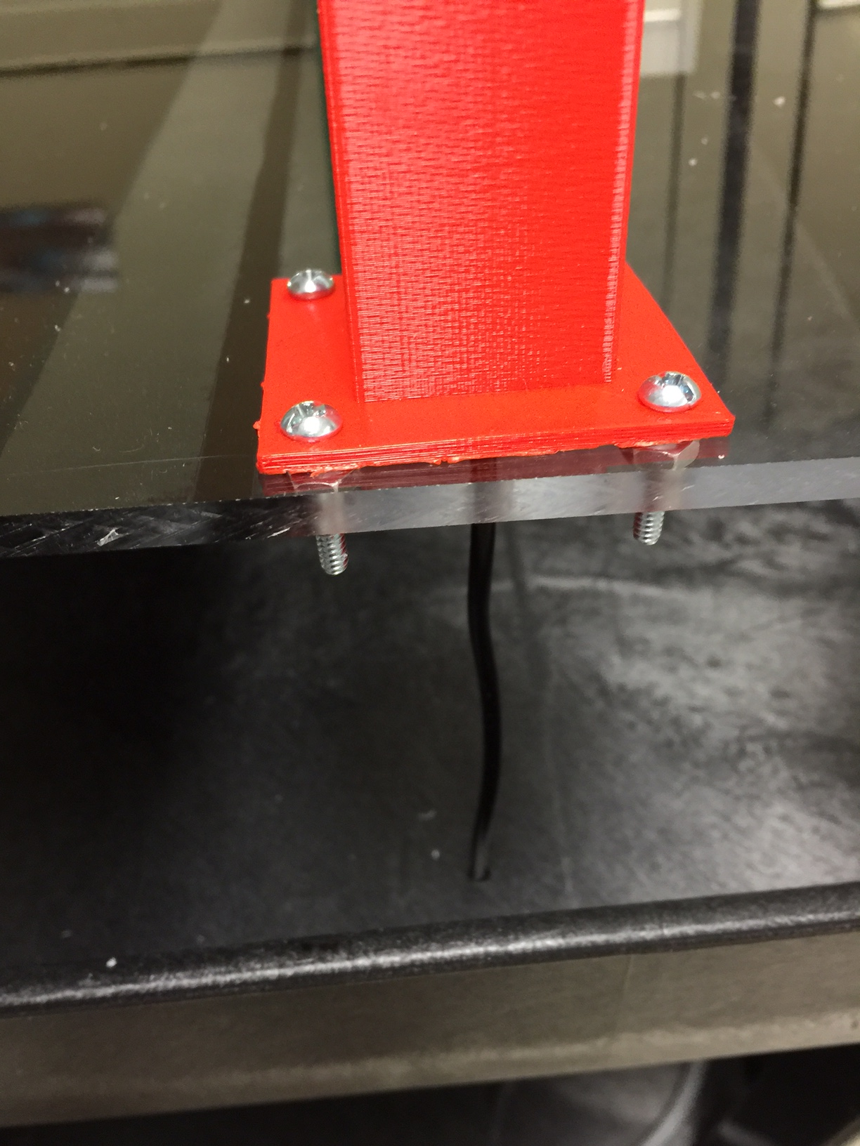
Figure 19 - Streetlight Housing Mounting

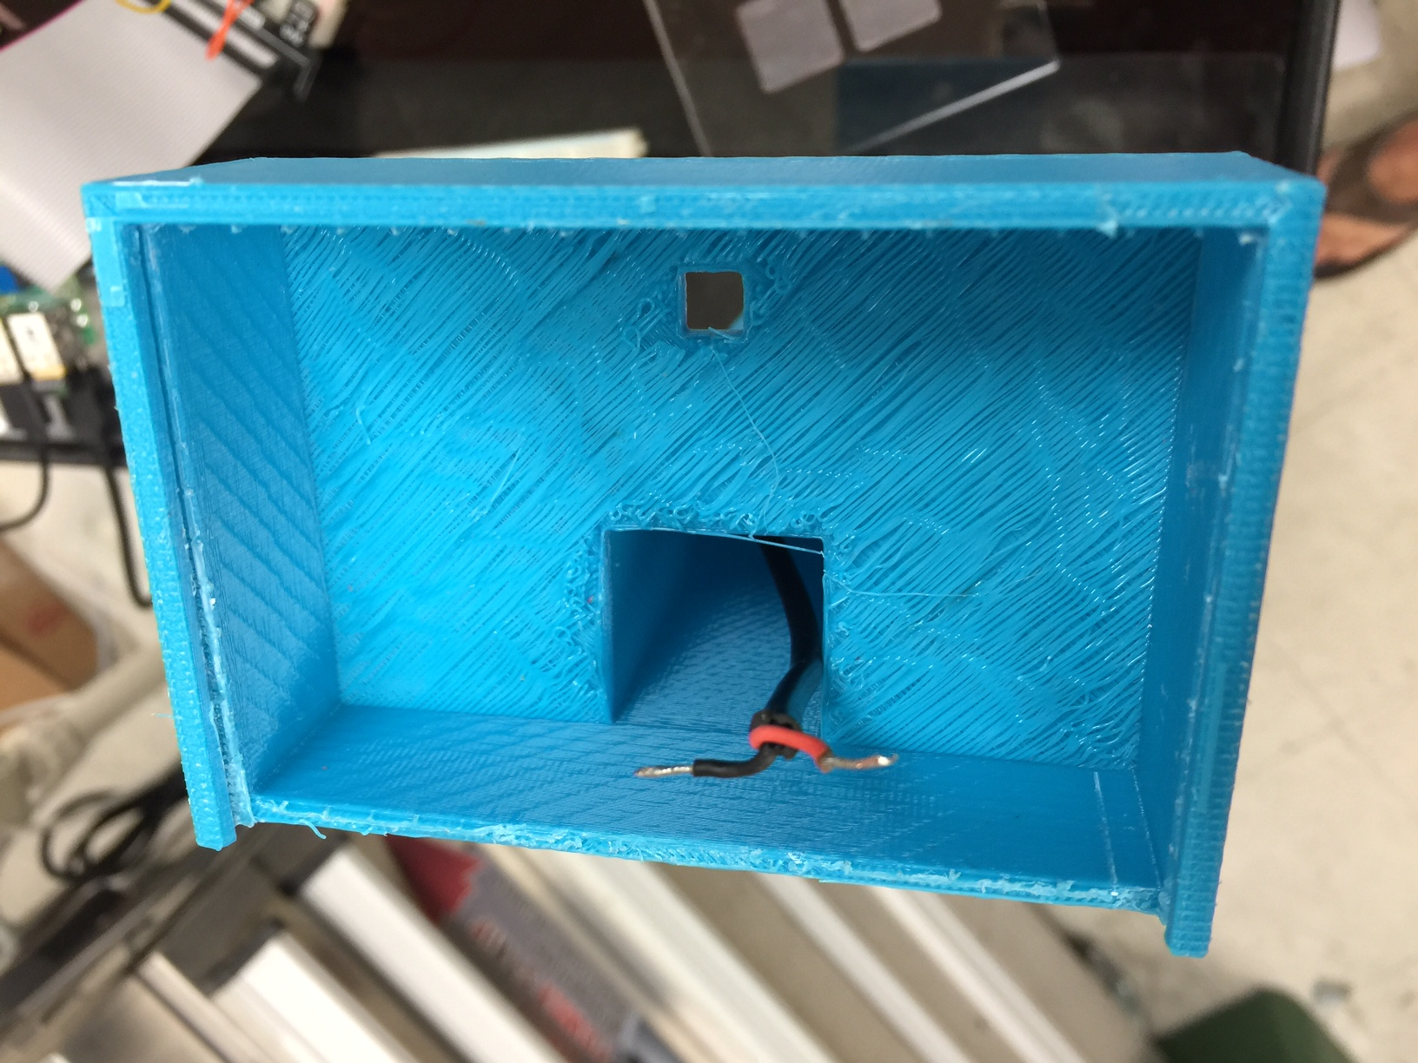
Figure 20 - Top Housing with Power Cable Fed

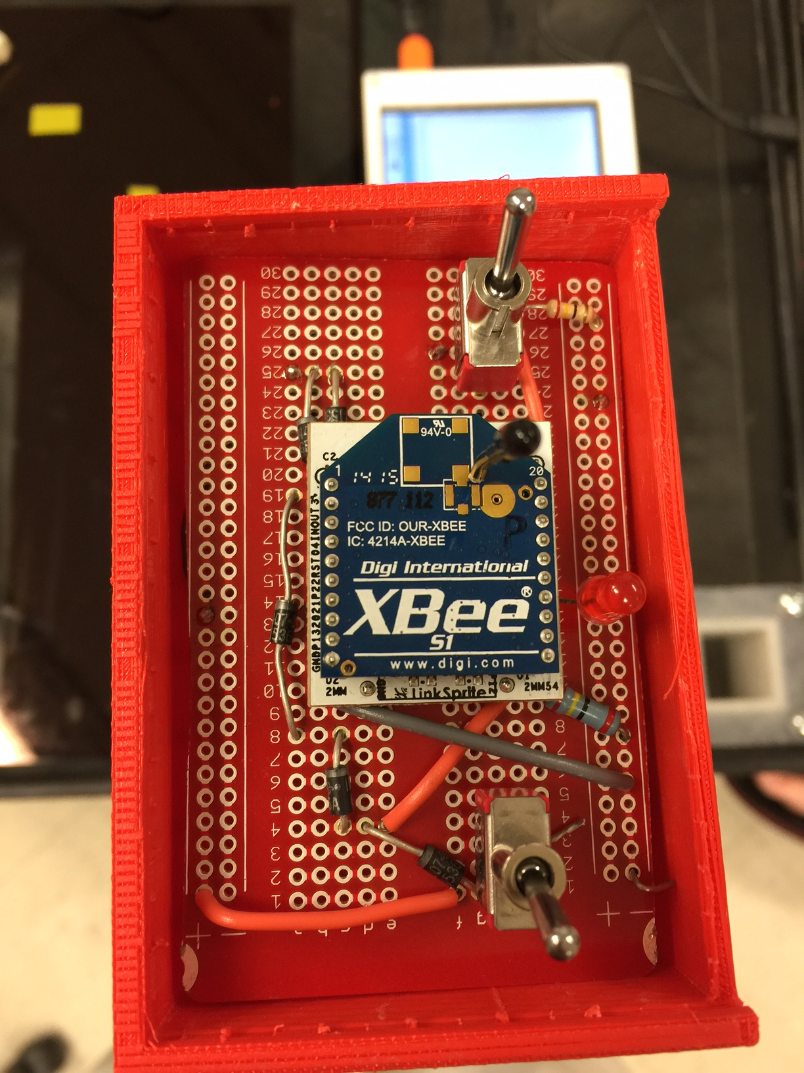
Figure 21 - Top Housing with Circuit

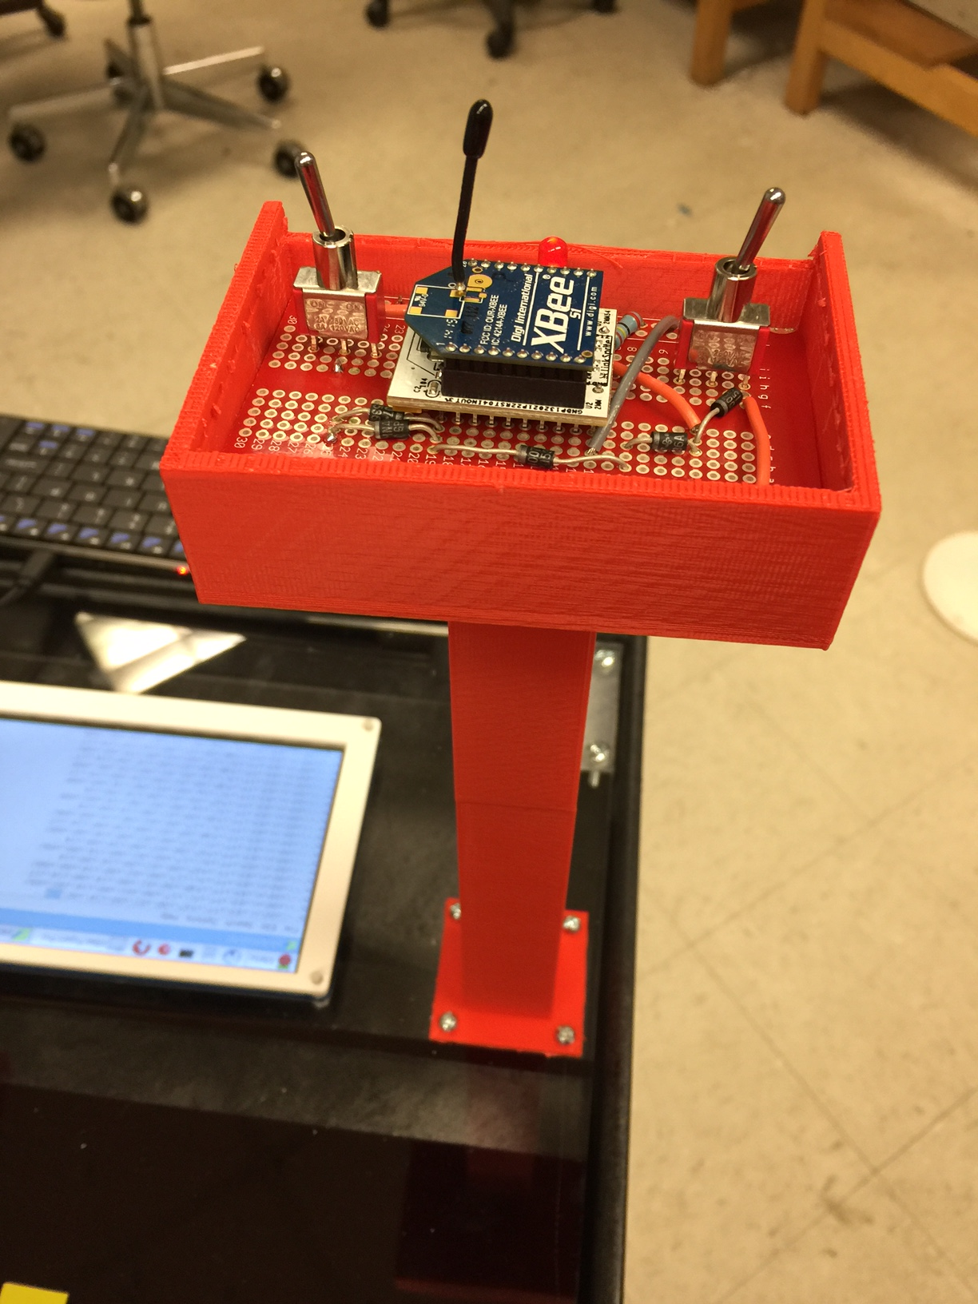
Figure 22 - Arial Housing/Circuit View

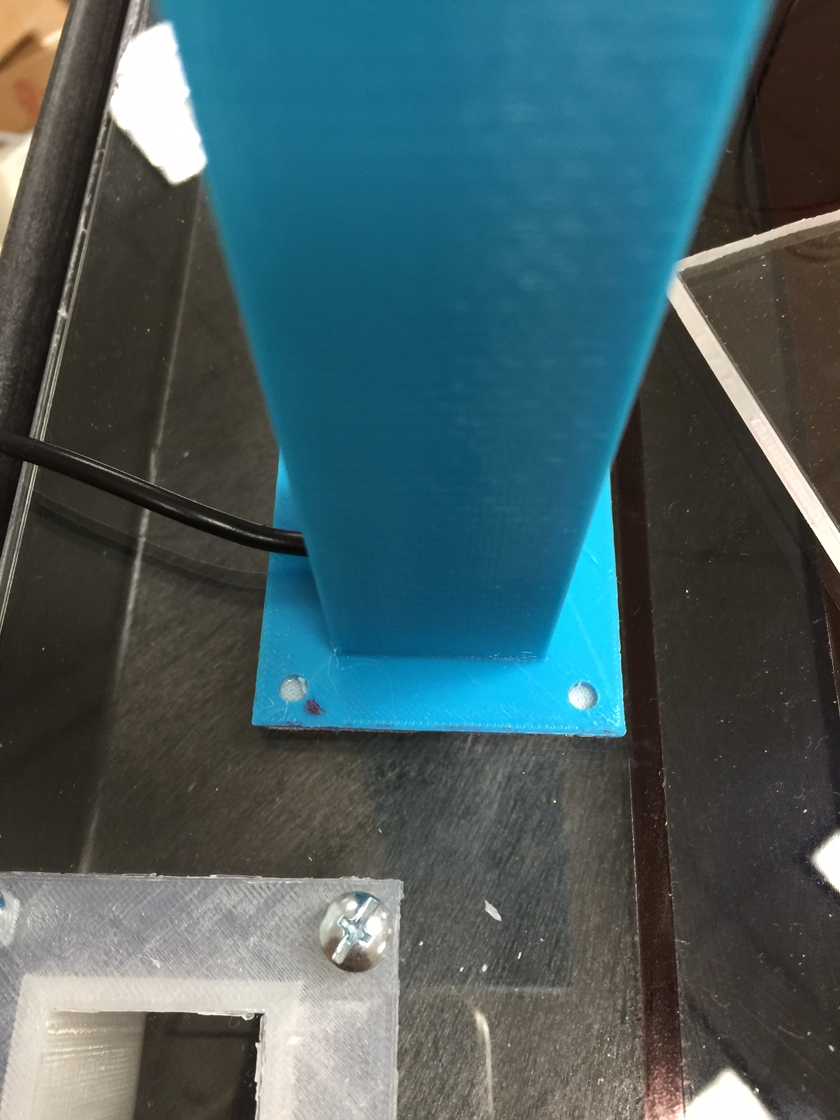
Figure 23 - Streetlight with Removable Base

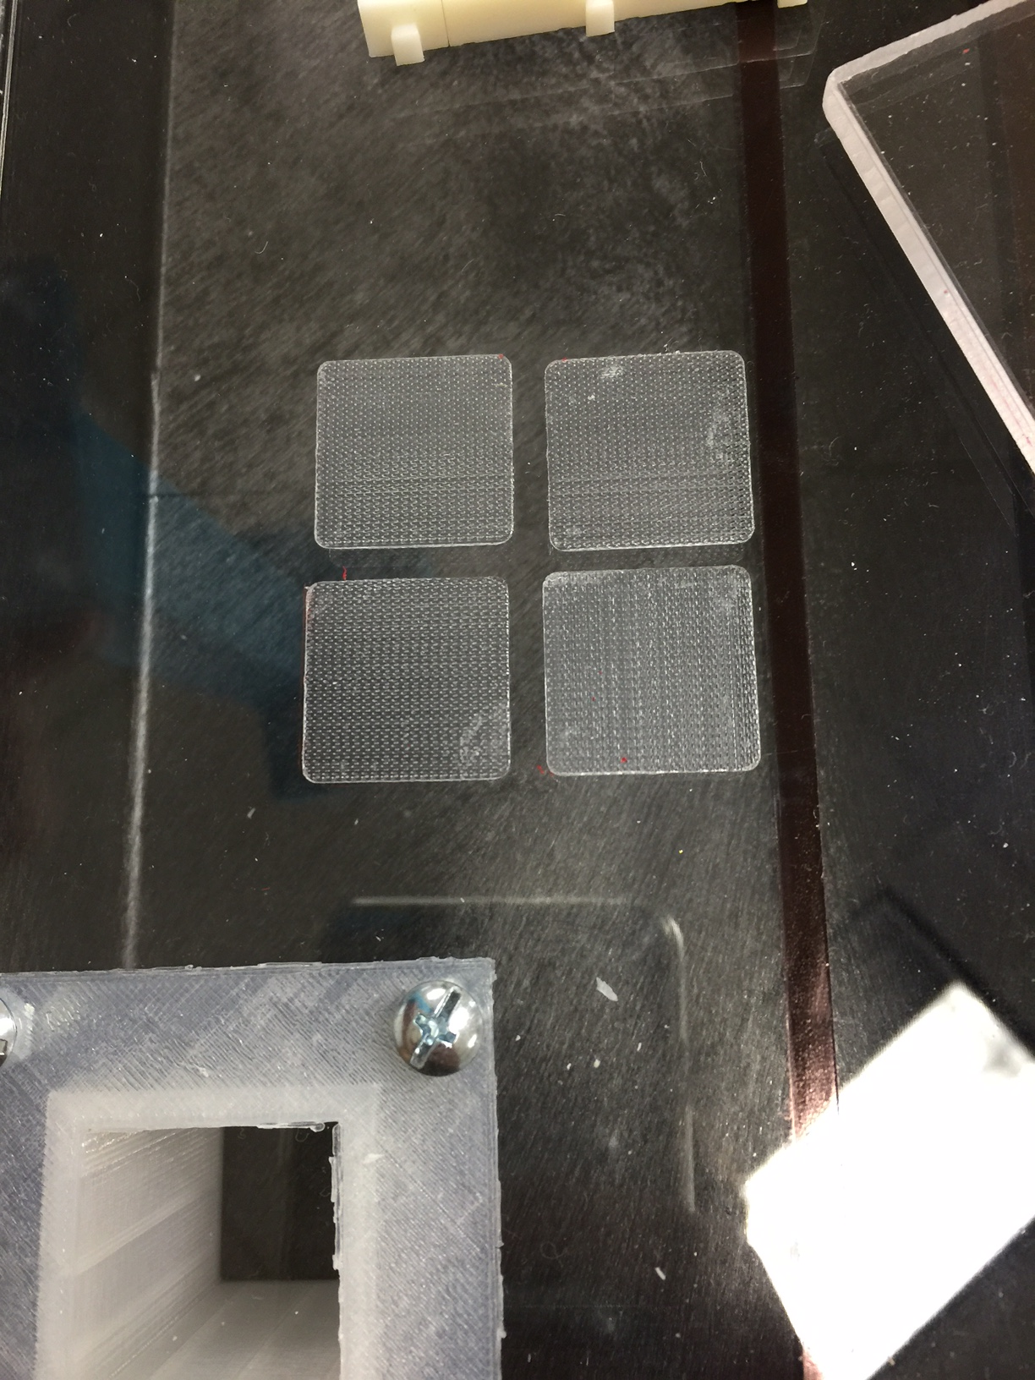
Figure 24 - Removable Base Area on Cart

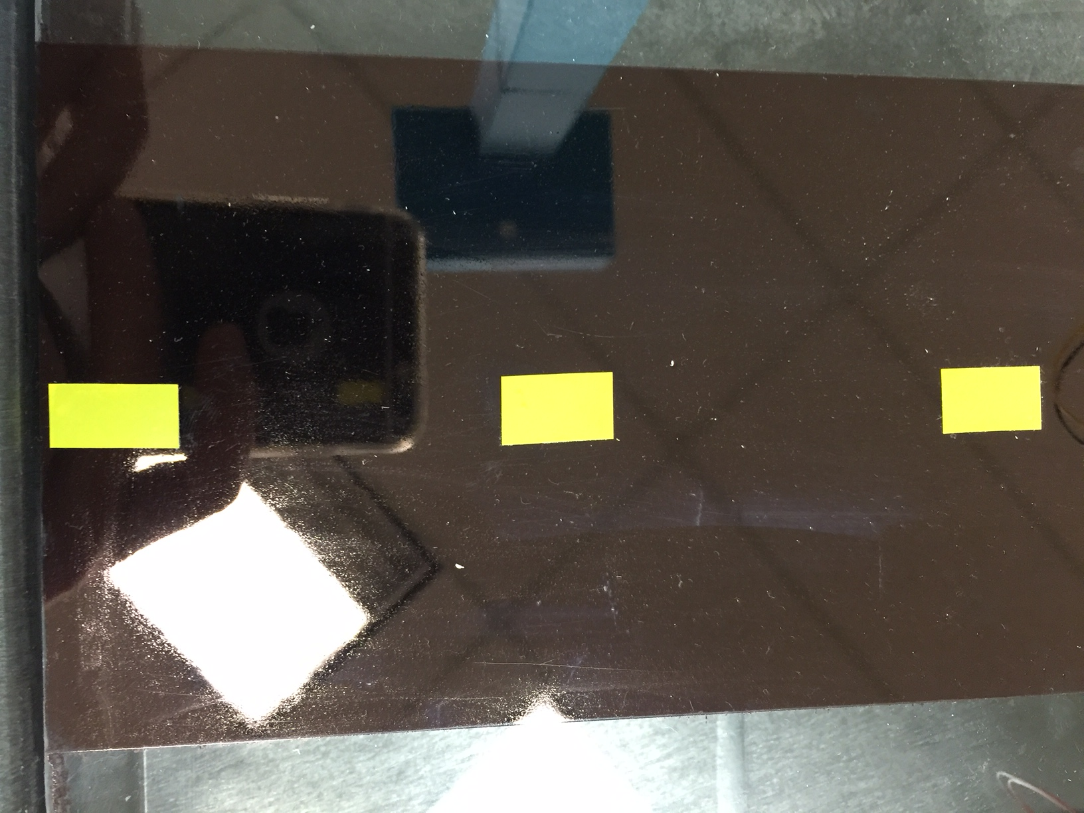
Figure 25 - Street Design

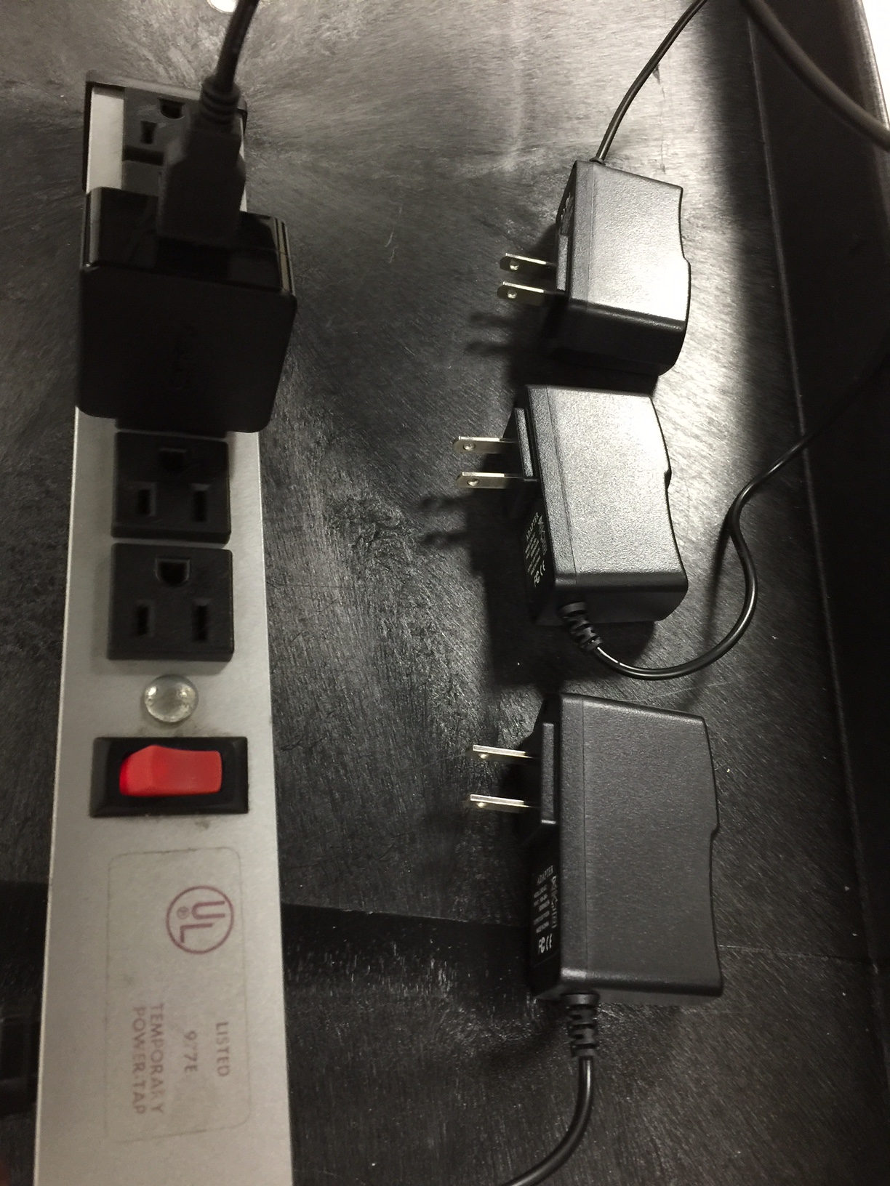
Figure 26 - Power Converters

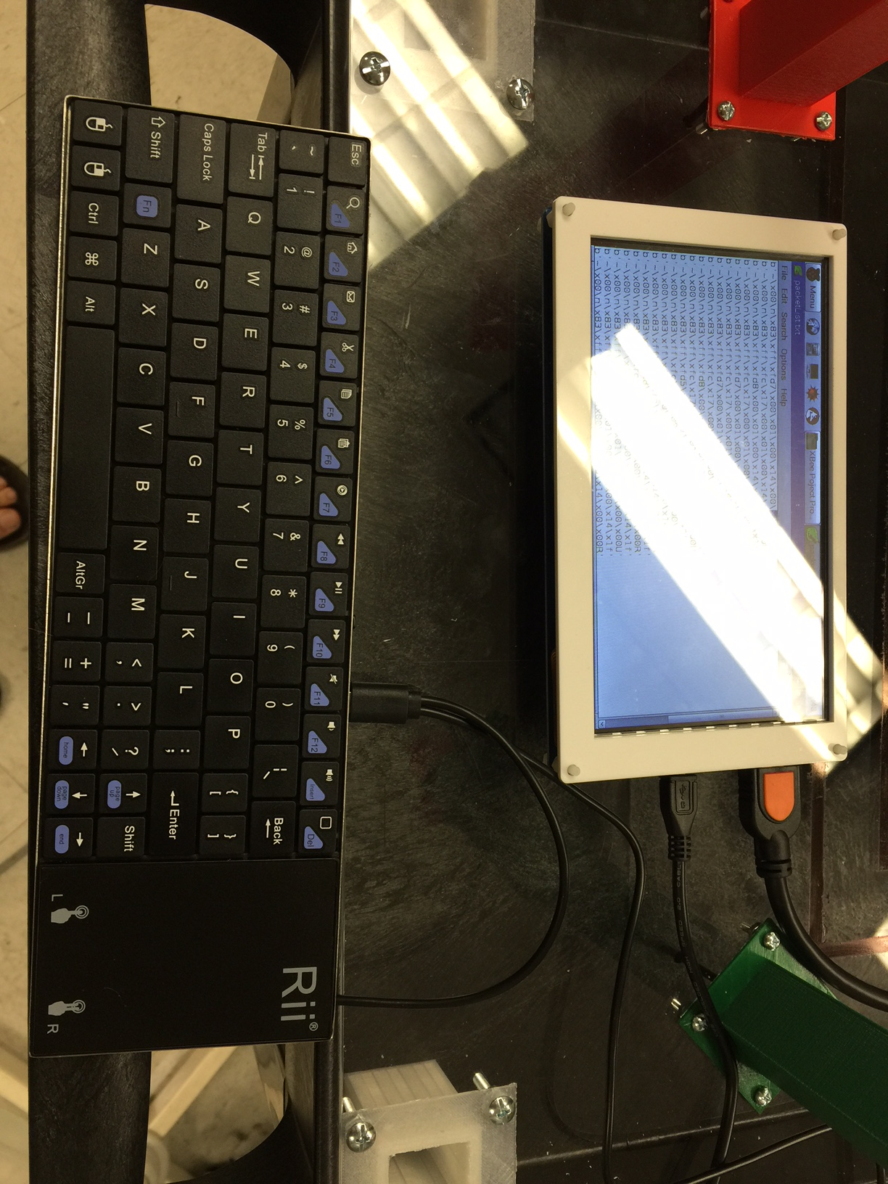
Figure 27 - UI Keyboard (LCD not mounted yet)

Troubleshooting
Problem: When running the code, the system won’t receive packets.
Solution: Make sure you are running the program using IDLE for Python 3, and not Python 2. The syntax is slightly different, so the code will run, but not work properly.

Problem: Packets are being split between lines making them hard to read.
Solution: Before running the program make sure that each XBee device is working properly and sending packets, this can be done by pressing 3 on the main menu.

Problem: Old dataPacket.txt get overwritten by new ones.
Solution: This is by design for ease of use. If you would like to save old dataPacket.txt files for your records, just rename them or move them to another directory. If there is no dataPacket.txt in the folder with the program user_interface.py a new one will be created.

Problem: The XBee is not transmitting the status of the streetlight and the back-up battery is not dead.
Solution: The XBee could be out of range from the central user interface. Test the XBee with a portable user interface to prove that it is functioning properly.

Problem: The XBee is not transmitting the status of the streetlight, the back-up battery is not dead, and the XBee is within the transmission range.
Solution: The XBee must be in sync with the user interface. The XBee will need to be set to the appropriate channel that the mesh network is operating on. This should have been done when the XBee was first set up, but if not can still be done with XCTU

Problem: The status of the streetlight shows that power has been lost but the light is on.
Solution: Check to make sure that the Smart Streetlight device was correctly installed. All wires should be secured in the proper place.

Problem: The user interface freezes or is unresponsive.
Solution: We currently have the user interface running from a low powered computer running Linux. The final product will not have this problem

Problem: Wheels on cart become stiff and squeaky.
Solution: Apply a small amount of silicone lubricant. If problem becomes constant, replace the wheel bearing.

Problem: XBee doesn’t transmit when the 5 volt power supply is disconnected.
Solution: First charge the battery with a 4 volt supply. If this doesn’t fix the problem then replace the battery.

Problem: If the Smart Streetlight device will not power on. (This can occur when the Red LED on board are not on when power is being applied.)
Solution: Check that the batteries are charged and properly connected. If issue persists consider replacing the battery. If a new battery still does not work. Feel free to contact us so your Smart Streetlights will be serviced.

Regular Maintenance
Battery Care:
- Keep unplugged when not in use to prevent loss of charge
- Store in dry areas to prevent acid build up
- Do not expose to unnecessary heat to prevent permanent capacity loss

LED Care:
- Supply with the appropriate amount of voltage to prevent overheating
- Turn off power when not in use to preserve the LED’s lifetime
- Evaluate lighting brightness and replace if one begins to dim

Cart Care:
- Keep wheels locked during a demonstration or while storing
- Do not place food or drinks on or around the cart
- Disconnect power when performing any maintenance
- Keep wheels lubricated to prevent obnoxious squeaking or stiffness

References
- "Pololu Robotics and Electronics." Pololu Robotics and Electronics. N.p., n.d. Web. 29 Oct. 2014. <http://www.pololu.com/>.
- RF Modules. Digital image. Arduino.CC. Arduino, n.d. Web. <http://arduino.cc/documents/datasheets/Z000001_XbeeRadioModule.pdf>.
- "ABS plus -P430: Production-Grade Thermoplastic for Design Series 3D Printers." (n.d.): n. pag. Stratasys. 2014. Web. 21 Oct. 2014. <http://www.stratasys.com/~/media/Main/Secure/Material%20Specs%20MS/Fortus-Material-Specs/Fortus-MS-ABSplus-01-13-web.pdf>.
- "McMaster-Carr." McMaster-Carr. N.p., 2014. Web. 31 Oct. 2014. <http://www.mcmaster.com/#timing-belts/=u92rk7>.

